**PRACTICAL EXAMINATION 01**Subject code: FER201m – SU 2023   
Duration: 85 minutes

FPT University is currently implementing the construction of a news website to promote the image and activities of the university, using the create-react-app technique to render a mobile-friendly website. The application requires the logo of the university to be displayed, a menu section for navigating within the website, and a contact modal next to the menu. When a user enters a keyword in the contact Modal, a popup will display information of contact form. Below the navigation menu, there will be a list of students (including id, image, name and address).

The student should put the code of the app in a zip file named "**FPTUniversity_code.zip**"   
(please avoid using the student's name or ID).

The student can write the code based on the specific tasks (using Redux architecture):

1. Create the component **Students** to render the information of Students (id, name, image, address). (3 marks)
2. Create the component **Contact** to render the information of the contact form (3 marks)
3. Create a beautiful interface using Bootstrap. (2 marks)
4. Using Redux architecture (2 marks)

The materials that the student must submit to the lsmdn system for marking include:

1. FPTUniversity_code.zip
2. A PDF file with screenshots of the application. If the app has errors and cannot render the view, please note "App has error" on the file.

**Note:**

* The images and the students.js file are located in the provided folder, which students can use for test.
* Students are allowed to use different versions of React to complete the test. Students are using Node.js version 16.
* During the file compression for submission, please exclude the node_modules folder.
* The interface should be able to be responsive on different device platforms, such as mobile.

*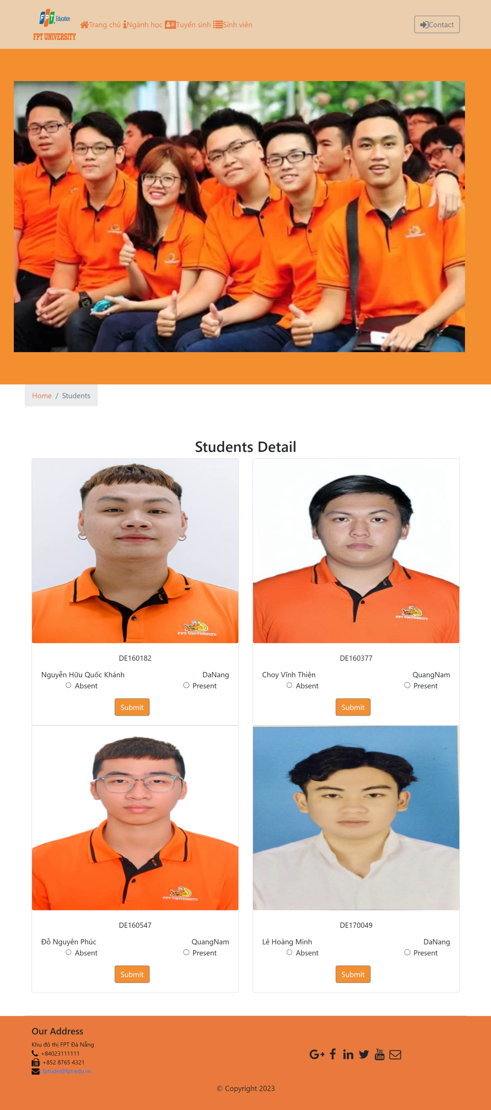.*

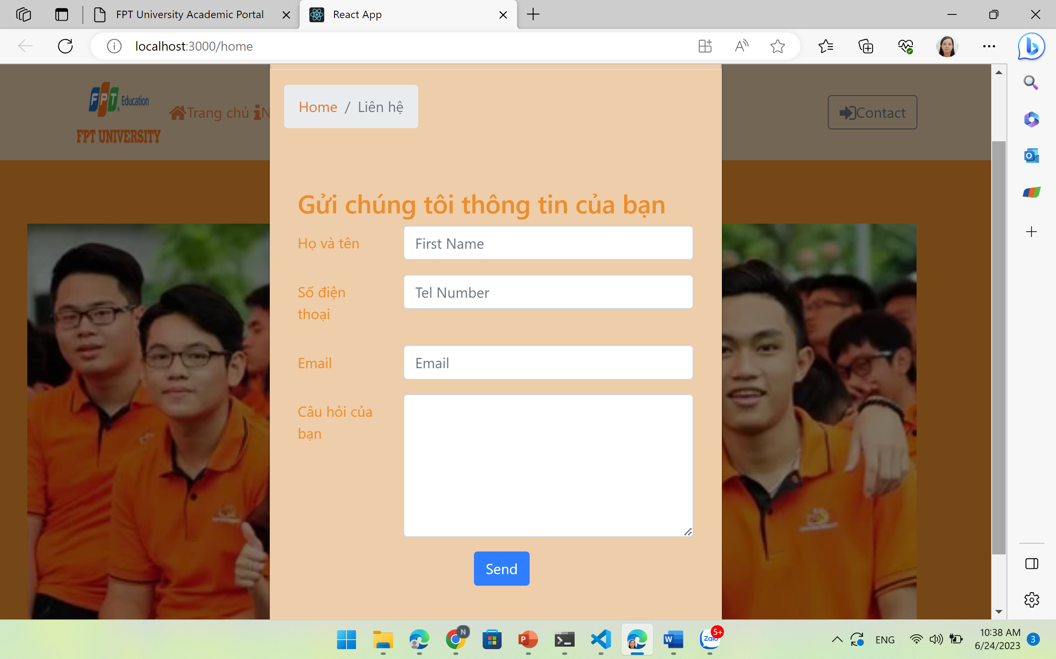

students.js

export const STUDENTS = [

    {

      id:'DE160182',

      name: 'Nguyễn Hữu Quốc Khánh',

      image: '/images/khanh.png',

      address: 'DaNang',

      featured: false,

    },

    {

      id:'DE160377',

      name: 'Choy Vĩnh Thiện',

      image: '/images/thien.png',

      address: 'QuangNam',

      featured: false

    },

    {

      id: 'DE160547',

      name: 'Đỗ Nguyên Phúc',

      image: '/images/phuc.png',

      address: 'QuangNam',

        featured: false

    },

    {

      id: 'DE170049',

      name: 'Lê Hoàng Minh',

      image: '/images/minh.png',

      address: 'DaNang',

      featured: true,

    }

  ];